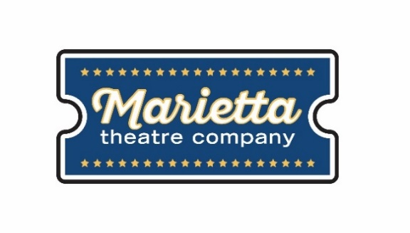

For more information:
Laurel Haislip
BRAVE Public Relations
404.233.3993
lhaislip@emailbrave.com
FOR IMMEDIATE RELEASE

Marietta Theatre Company opens second show of the season, The Toxic Avenger,
October 19 - November 3
Spectators invited to downtown Marietta for upROARious laughs about quirky super hero!

MARIETTA, Ga. (October 1, 2018) – Marietta Theatre Company is making a splash into their second season with The Toxic Avenger, a monstrously funny rock musical that tells the story of a man with a dream to save the world, but faces a tragedy that ultimately helps him in the long run. The Toxic Avenger, set to run October 19 through November 3 at the Lyric Studio on the Square, is a side-splitting comedy written by David Bryan and Joe DiPietro, the Tony award-winning writers behind the musical “Memphis.”

“Those who have seen the 1984 movie will know exactly why we chose to add The Toxic Avenger to our line-up this season,” said Blaine Clotfelter, president and co-founder of the Marietta Theatre Company. “Thanks to the support of our loyal patrons, we look forward to showing the people of Atlanta what we’re made of this season and bring them even more fun on the stage!”
The tongue-in-cheek musical follows the story of Melvin Ferd III, who wants to clean up Tromaville, the most polluted town in New Jersey. A wrench is thrown into his plans when the goons who are working for the Mayor throw him into a vat of radioactive waste. Melvin reemerges as The Toxic Avenger, Jersey’s first super hero. Known adoringly as “Toxie,” he sets out on his journey to save New Jersey, end global warming and capture the heart of the town’s blind librarian.
The cast is full of hilarious characters that the audience will come to know and love including Melvin Ferd III/ The Toxic Avenger (Claudio Pestana); his girlfriend, the blind librarian Sarah (Sophia Decker) and the evil Mayor Babs Belgoody/Ma Ferd (Janine DeMichele Baggett). The show also stars (PJ Woods) and (John Jenkins), who show off their talents by playing multiple zany and memorable characters.
The Toxic Avenger will play at the Lyric Studio on the Square from October 19 through November 3 with shows at 8 p.m. Thursday – Saturday and 3 p.m. on Sunday. Individual tickets ($25) and VIP tables for four with a bottle of wine ($125) are on sale now at www.mariettatheatre.tix.com. Audiences are also invited to purchase a season subscription and save 20 percent to enjoy the remaining four shows in Marietta Theatre Company's 2018-19 season, including The Toxic Avenger, I Love You Because, You're a Good Man Charlie Brown and Altar Boyz.

For more information on Marietta Theatre Company and to stay up to date on upcoming season information, please visit mariettatheatre.com or follow along on Facebook and Instagram.

About Marietta Theatre Company:
Marietta Theatre Company (MTC Players, Inc.) is a domestic 501(c)(3) and winner of nine 2018 Metropolitan Atlanta Theater Awards in its inaugural season. The theater is proud of its mission to provide an atmosphere for the community to experience life together and introduce patrons to outstanding local talent all while supporting local charities. To stay updated on Marietta Theatre Company's latest news and performance schedule, join their email list by visiting www.mariettatheatre.com/join-our-email-list/.
###

